**ITERATION STATEMENTS AND**

**JUMP STATEMENTS**

**LAB # 4**



**Spring 2022**

**CSE102L Computer Programming Lab**

Submitted by: **Ali Asghar**

Registration No. : **21PWCSE2059**

Class Section: **C**

“On my honor, as student of University of Engineering and Technology, I have neither given nor received unauthorized assistance on this academic work.”

Student Signature: ______________

Submitted to:

**Engr. Abdullah Hamid**

July 4, 2022

Department of Computer Systems Engineering

University of Engineering and Technology, Peshawar

**Lab Objective(s)**

* To understand the programming using iteration statements like while, do-while and for Loop and jump statements like continue, break, return and goto statement.

**TASK # 1:**

**Title:**

Write a program to create Simple Calculator using switch case….output from the previous inputs).

**CODE SCREENSHOTS:**

Here are the screenshots of the code.

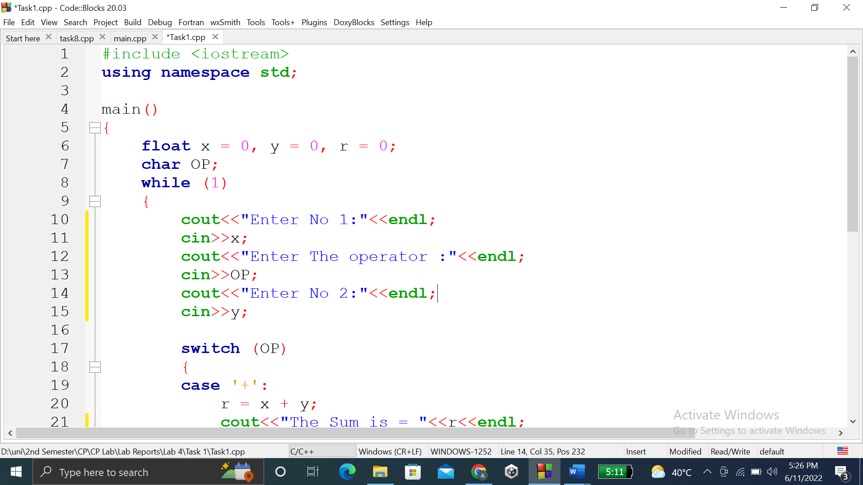

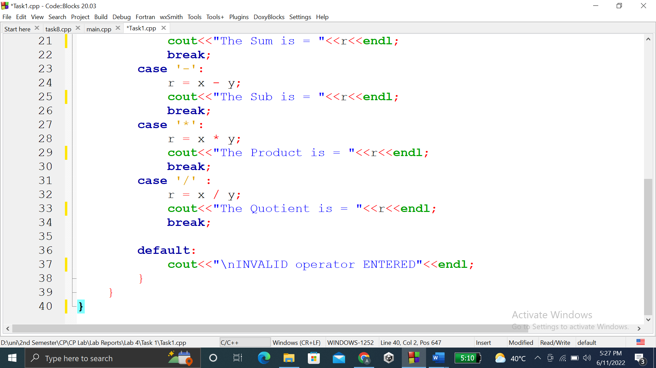

### **OUTPUT (COMPILATION, DEBUGGING & TESTING):**

Here is the screenshot of the output of above code.

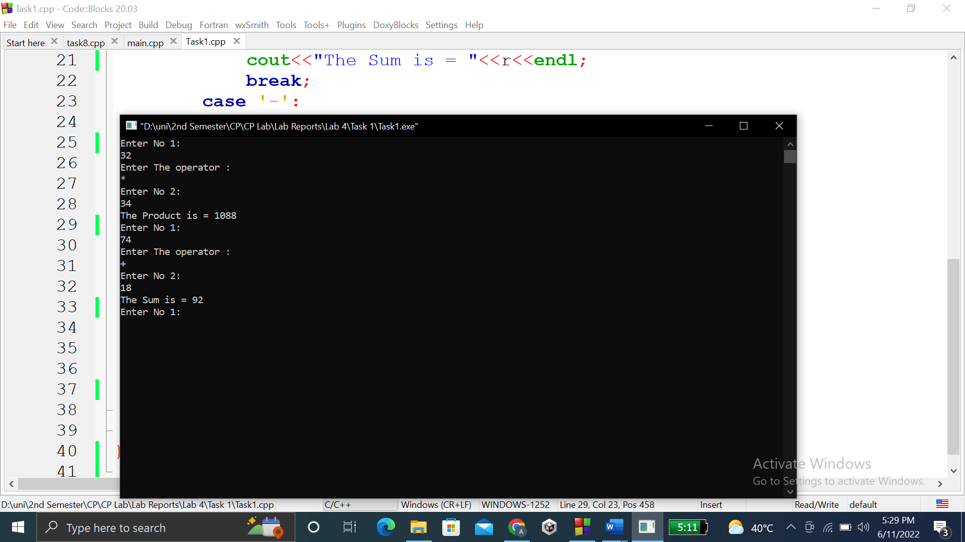

**TASK # 2:**

**Title:**

Write a program that takes a number as input, checks it if it is between………the program should end.

**CODE SCREENSHOTS:**

Here is the screenshot of the code.

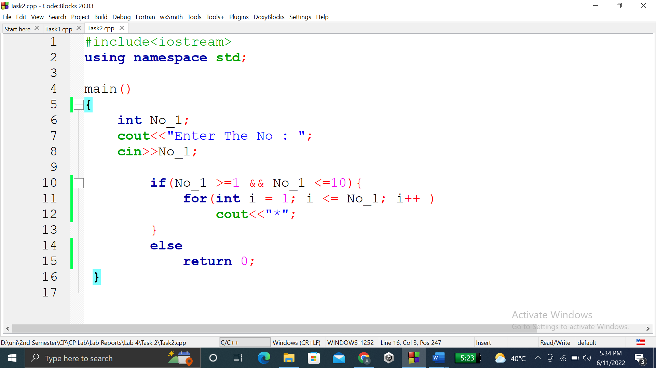

### **OUTPUT (COMPILATION, DEBUGGING & TESTING):**

Here is the screenshot of the output of above code.

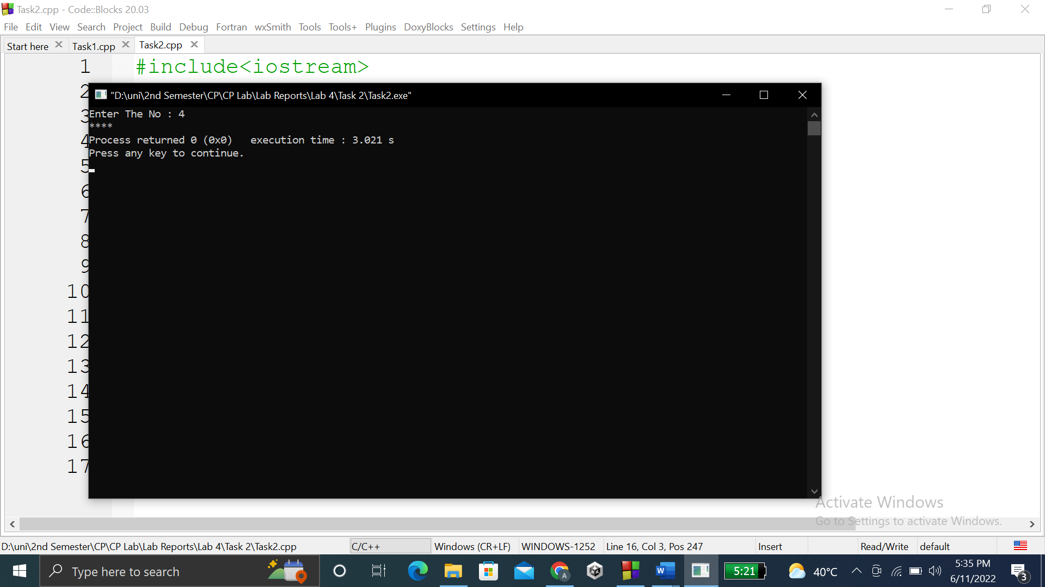

**TASK # 3:**

**Title:**

Write a program to find Factorial of a number.

**CODE SCREENSHOTS:**

Here is the screenshot of the code.

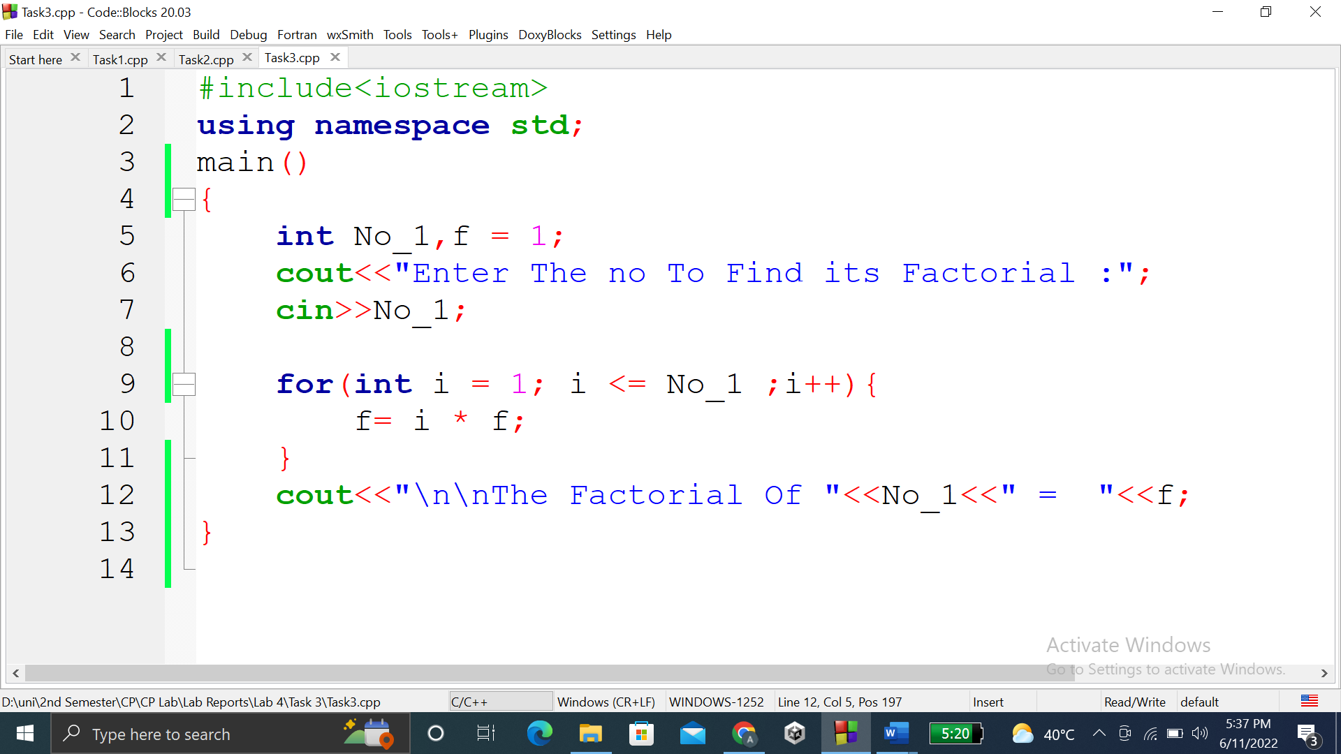

### **OUTPUT (COMPILATION, DEBUGGING & TESTING):**

Here is the screenshot of the output of above code.

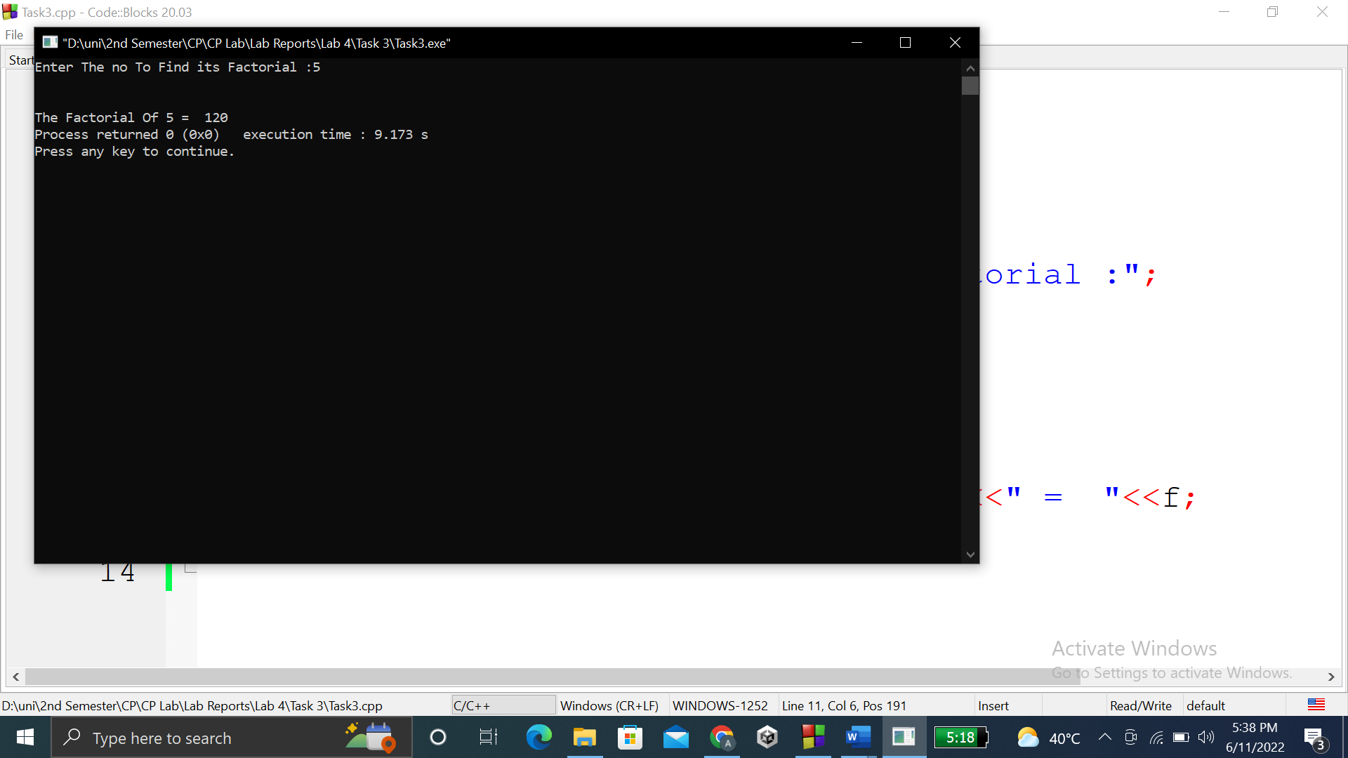

**TASK # 4:**

**Title:**

Write a program to print multiplication table of any number.

**CODE SCREENSHOTS:**

Here is the screenshot of the code.

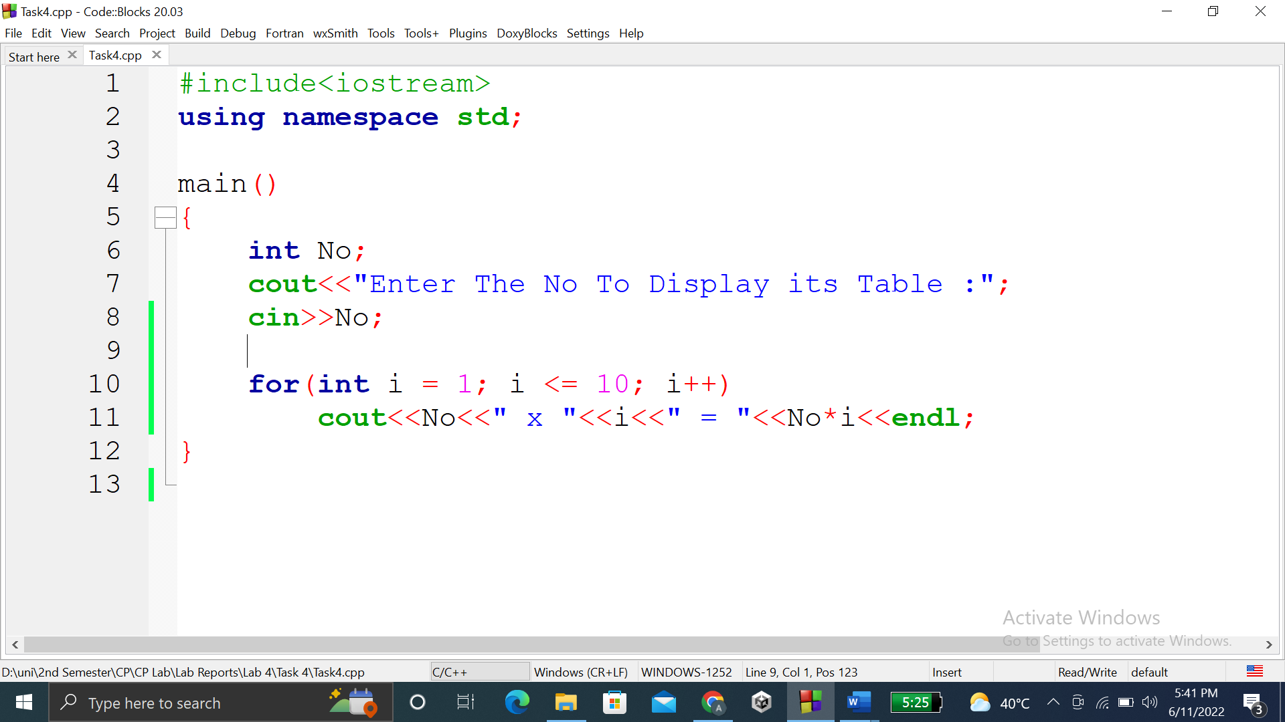

### **OUTPUT (COMPILATION, DEBUGGING & TESTING):**

Here is the screenshot of the output of above code.

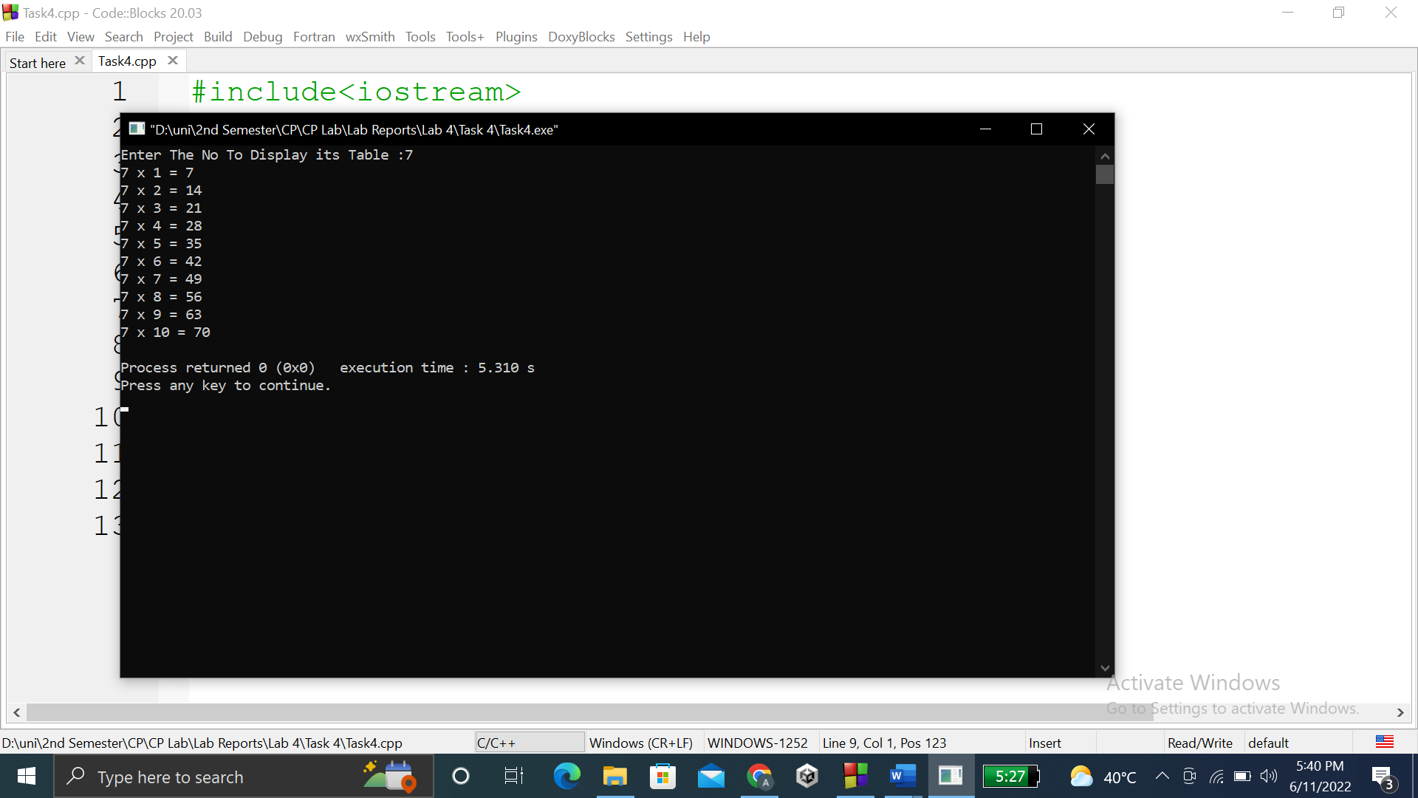

**TASK # 5:**

**Title:**

Write a program to input two integer numbers and display the sum of even…….two input numbers.

**CODE SCREENSHOTS:**

Here is the screenshot of the code.

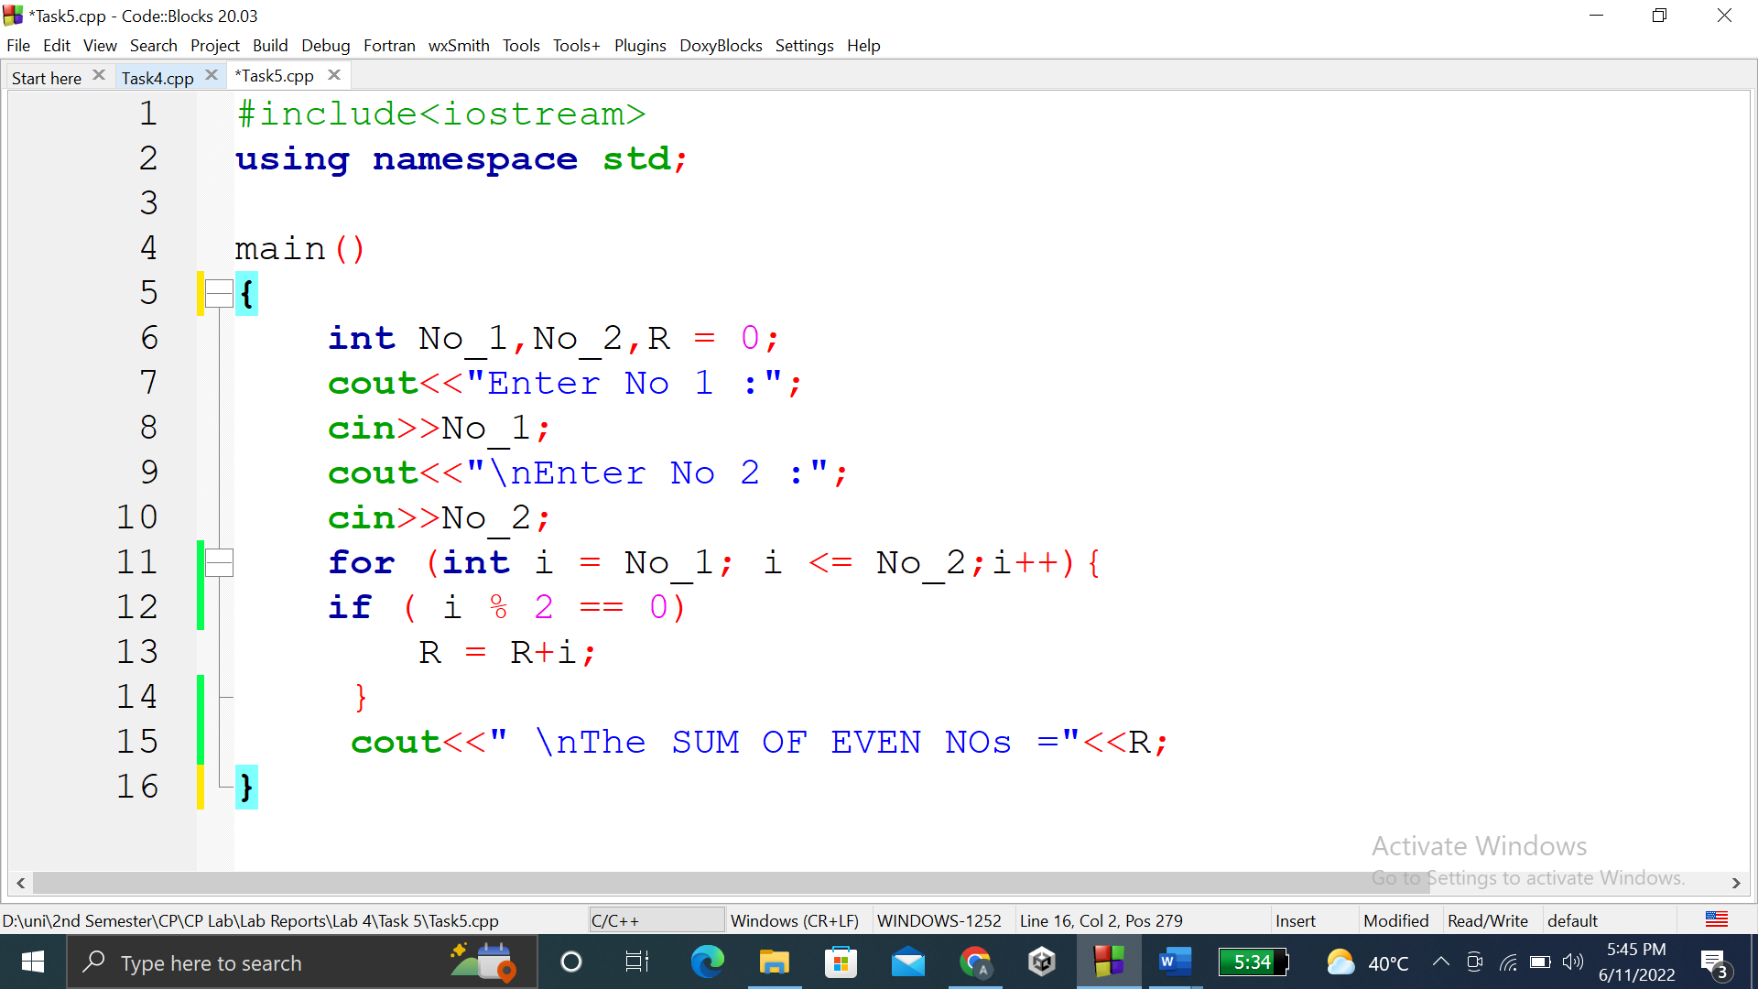

### **OUTPUT (COMPILATION, DEBUGGING & TESTING):**

Here is the screenshot of the output of above code.

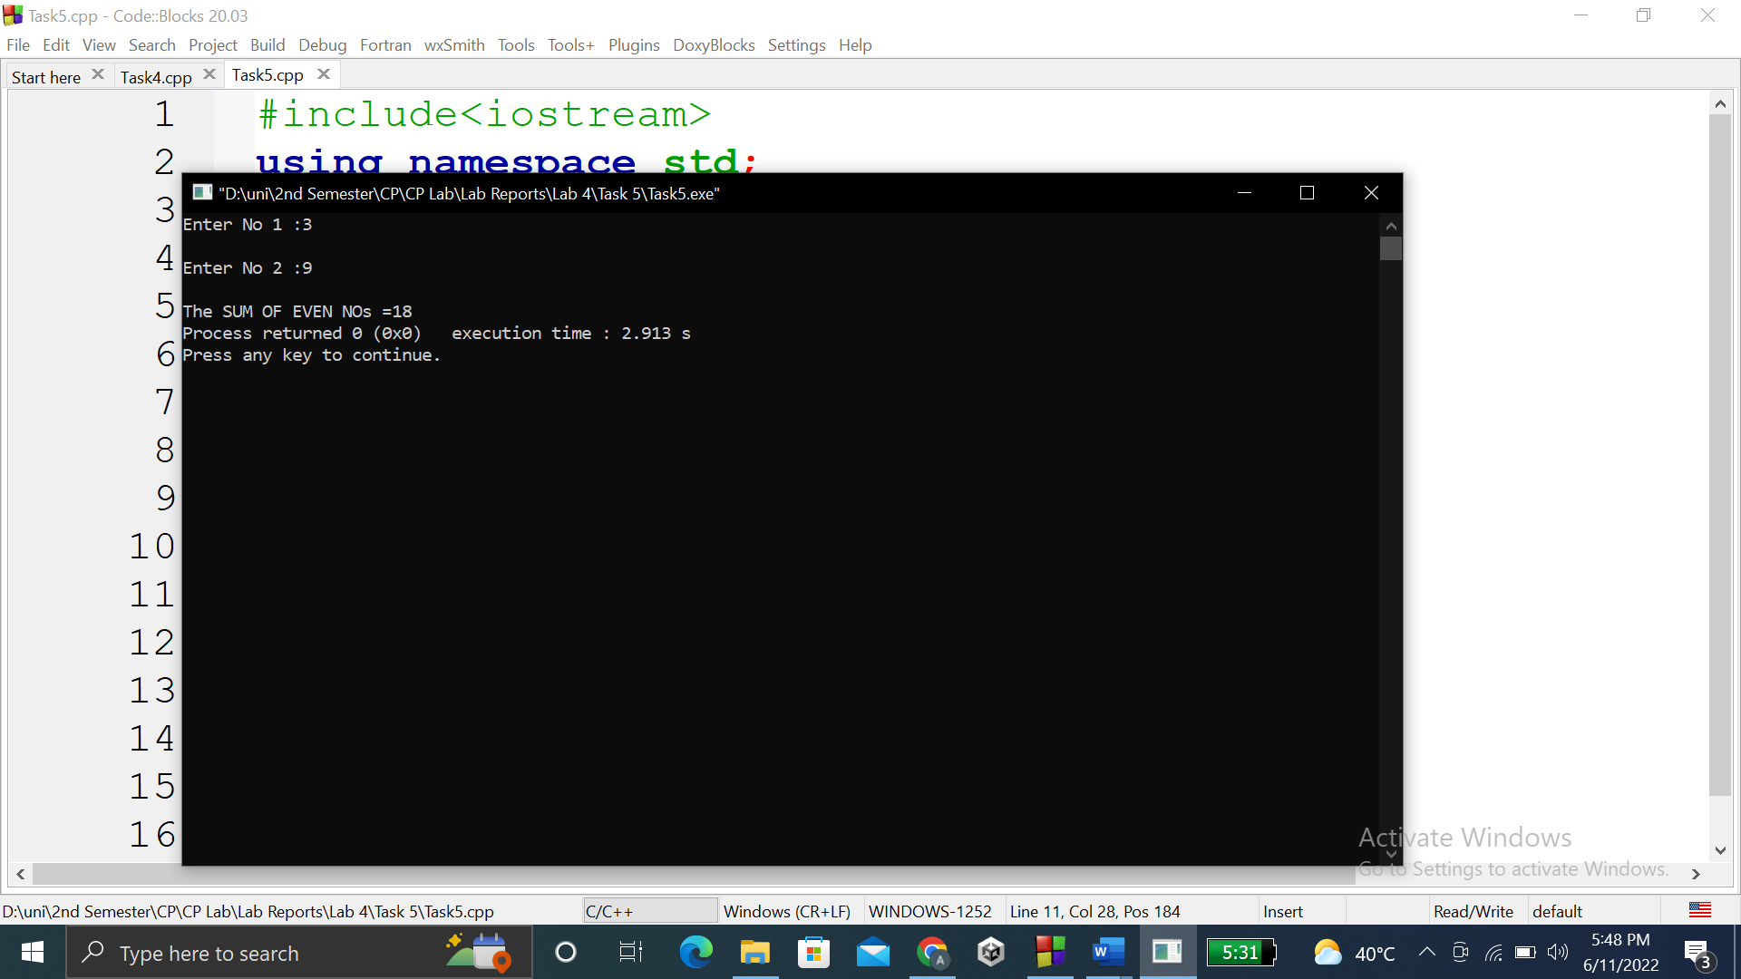

**TASK # 6:**

**Title:**

Write a program to print all-natural numbers in reverse (from n to 1).

**CODE SCREENSHOTS:**

Here is the screenshot of the code.

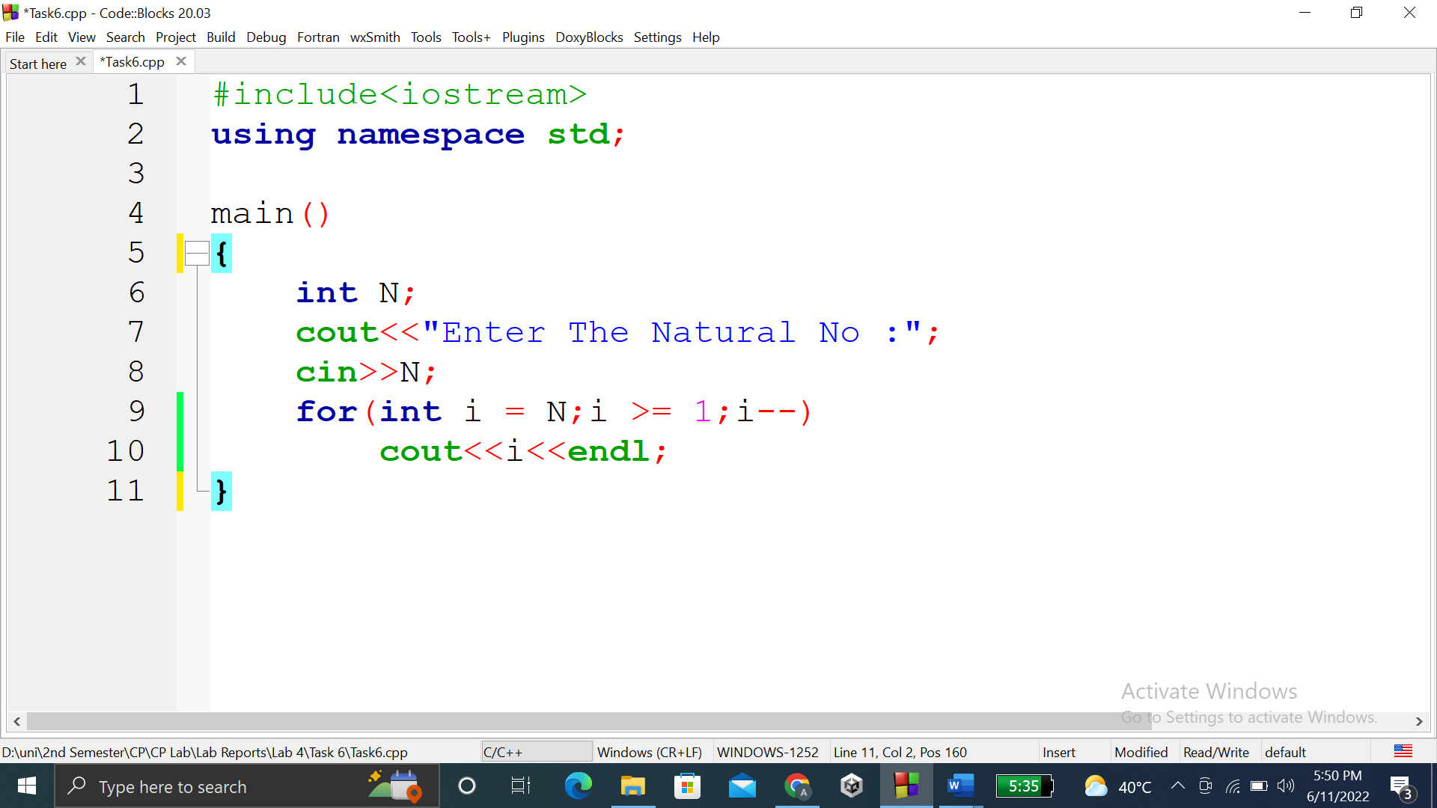

### **OUTPUT (COMPILATION, DEBUGGING & TESTING):**

Here is the screenshot of the output of above code.

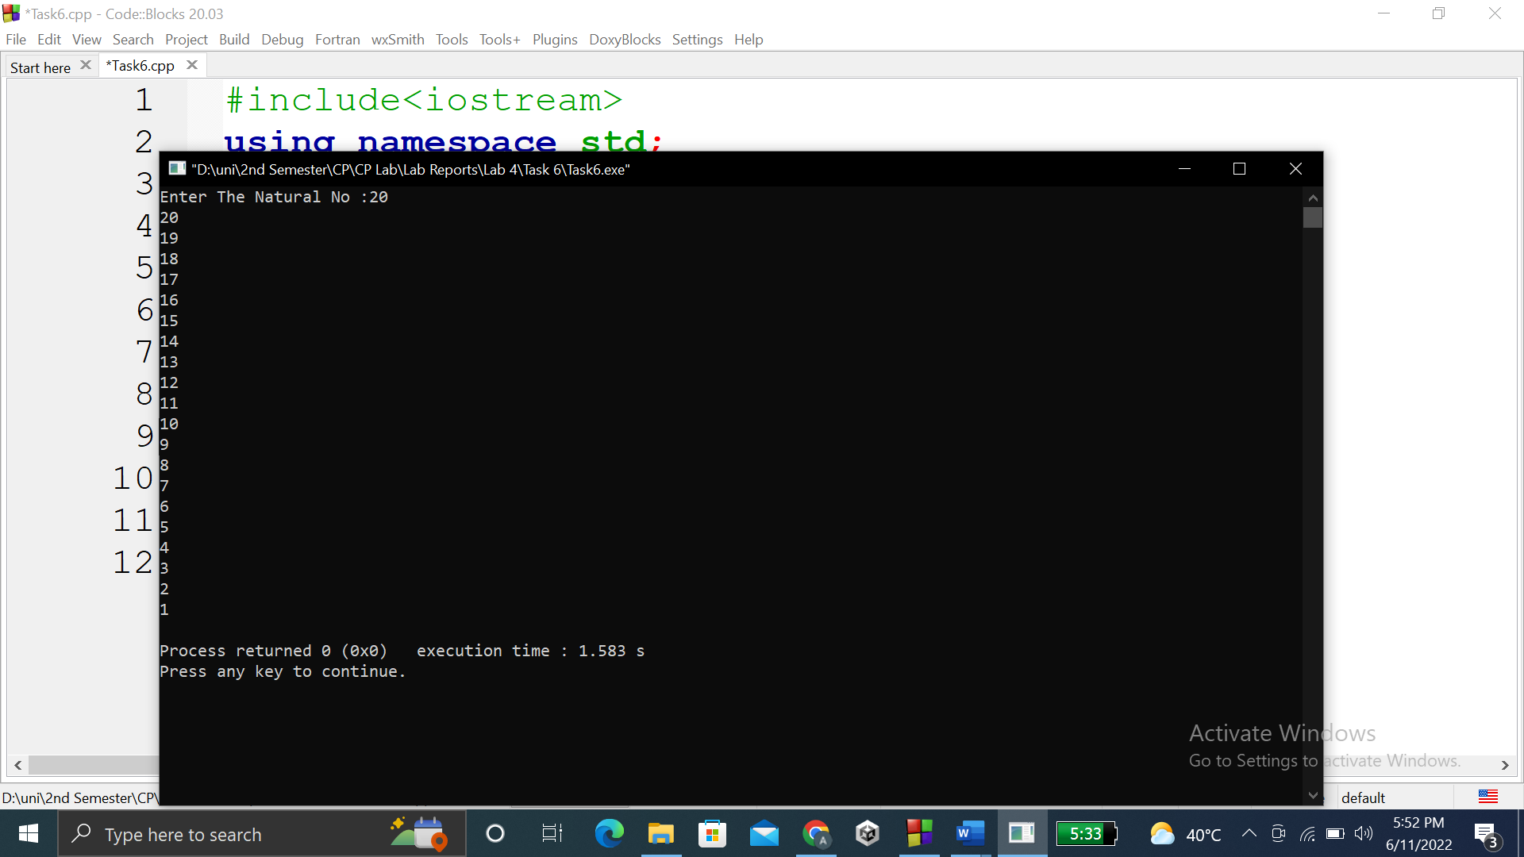

**TASK # 7:**

**Title:**

Write a program that takes the base and exponent as input and display the result of power.

**CODE SCREENSHOTS:**

Here is the screenshot of the code.

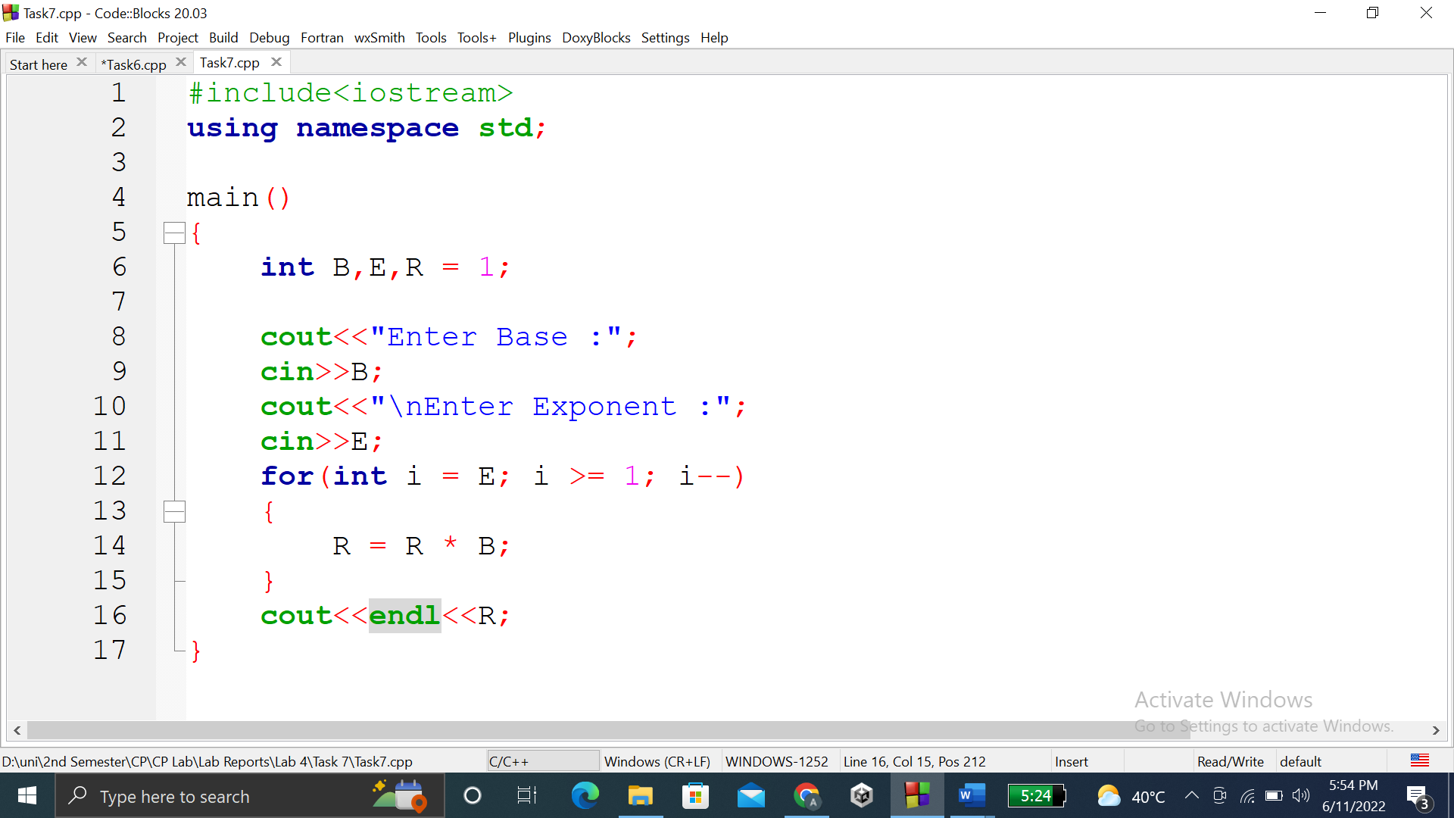

### **OUTPUT (COMPILATION, DEBUGGING & TESTING):**

Here is the screenshot of the output of above code.

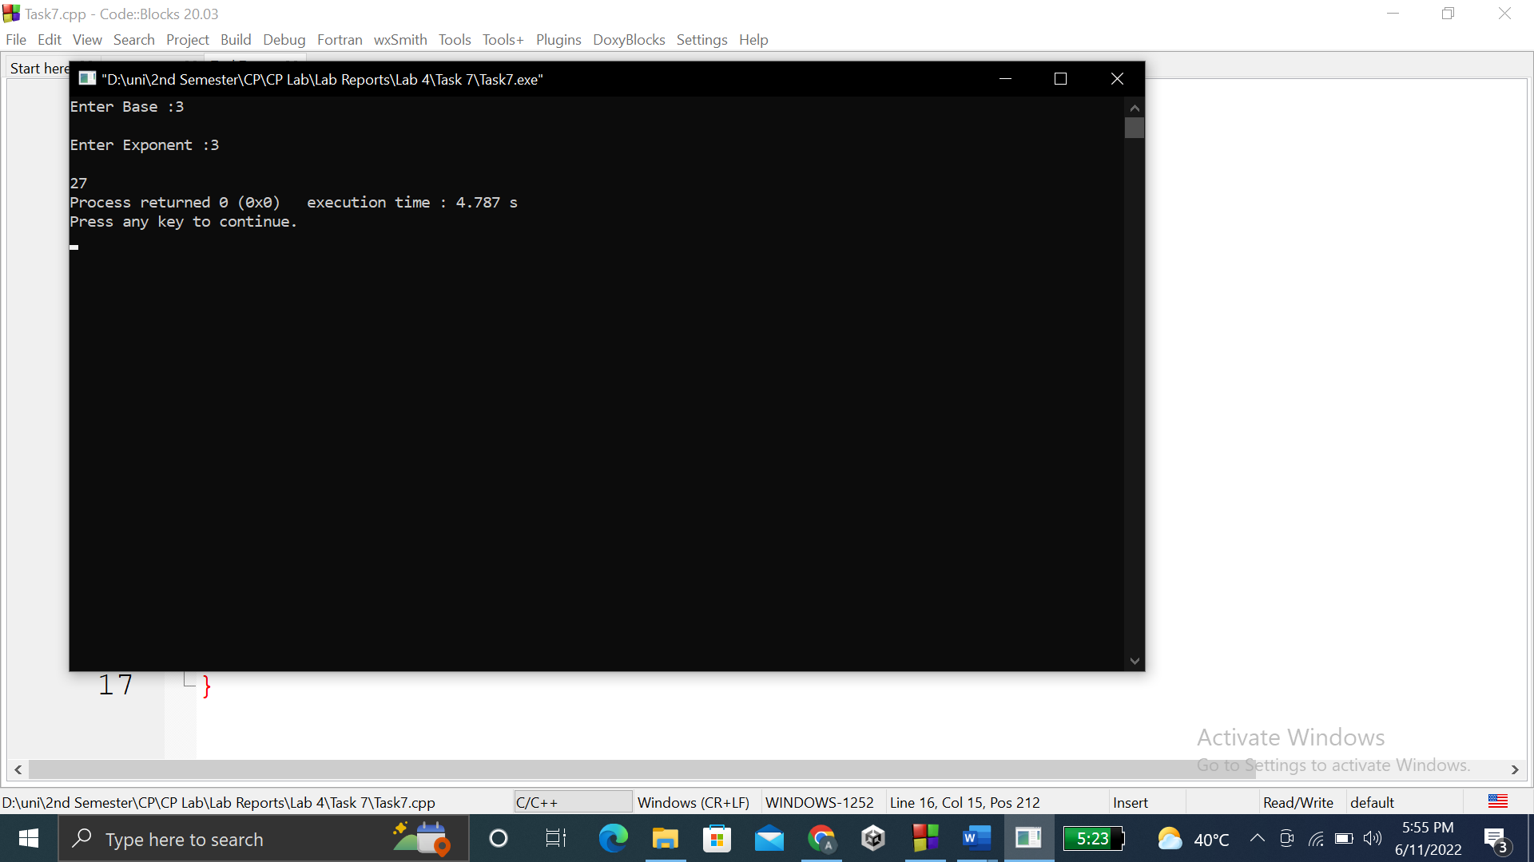

**TASK # 8:**

**Title:**

Write a program that prints your name and registration number 10 times………..and registration number.

**CODE SCREENSHOTS:**

Here is the screenshot of the code.

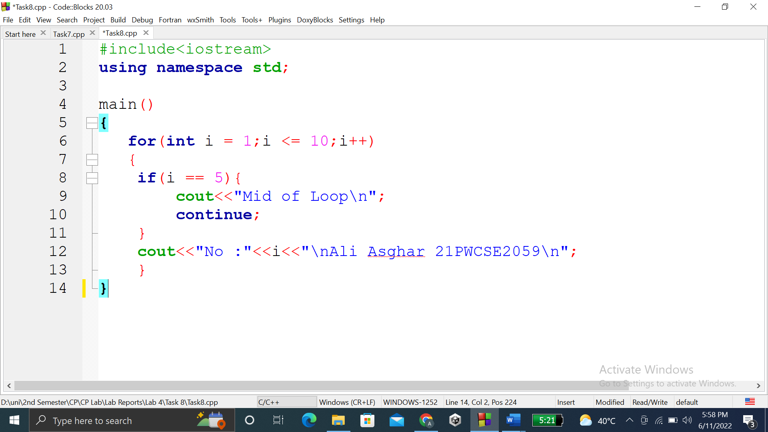

### **OUTPUT (COMPILATION, DEBUGGING & TESTING):**

Here is the screenshot of the output of above code.

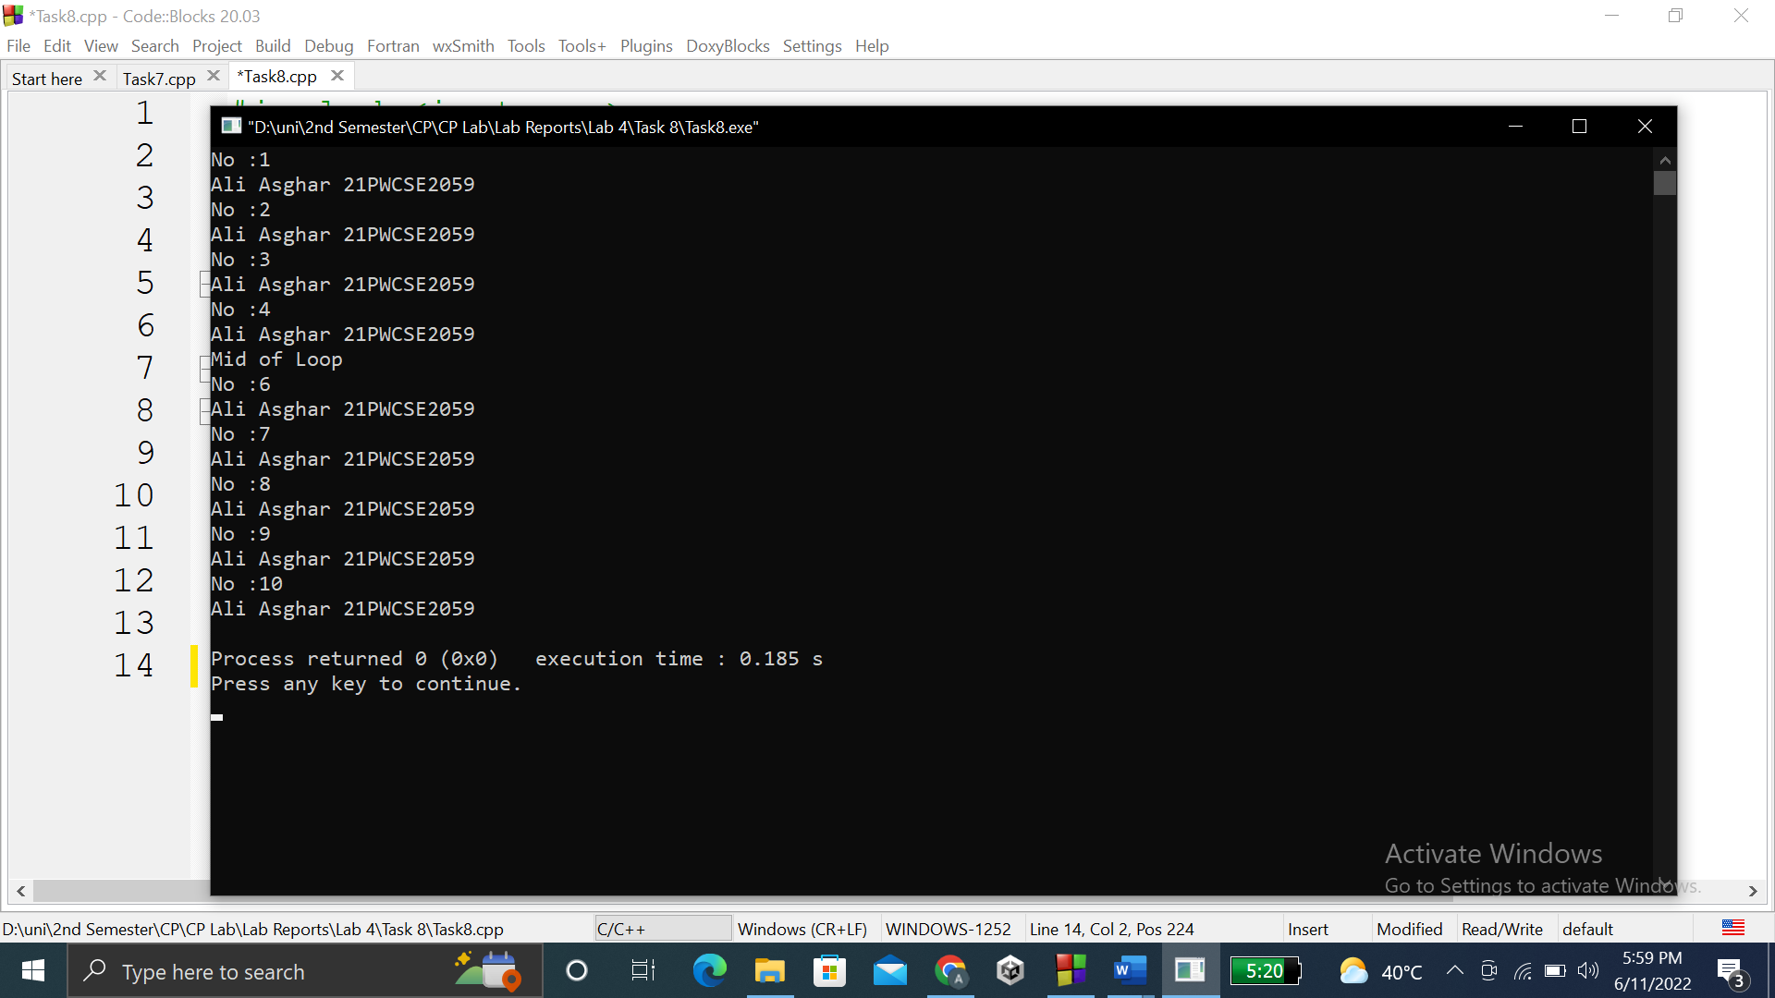

**TASK # 9:**

**Title:**

Write a program that performs a survey tally on beverages……..from the following list:

**CODE SCREENSHOTS:**

Here are the screenshots of the code.

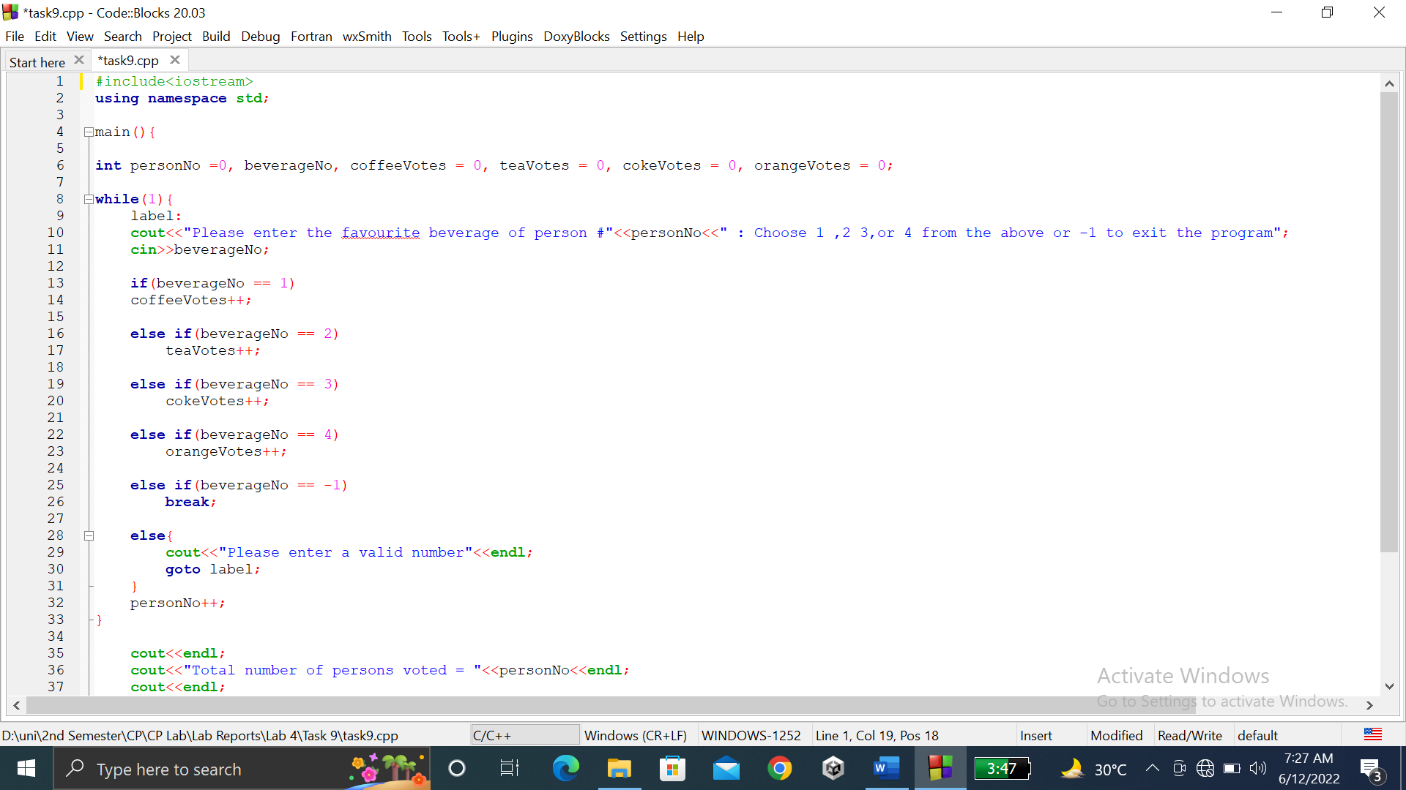

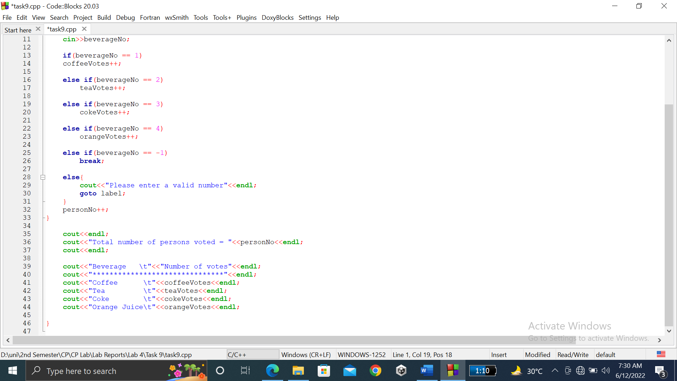

### **OUTPUT (COMPILATION, DEBUGGING & TESTING):**

Here is the screenshot of the output of above code.

